**Lab 5: Loops**

**Question1:**

Write a program that reads an unspecified number of integers, determines how many positive and negative values have been read, and computes the total and average of the input values (not counting zeros). Your program ends with the input **0**. Display the average as a floating-point number. Here is a sample run:

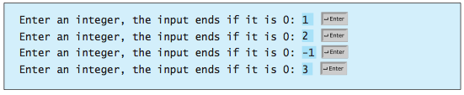

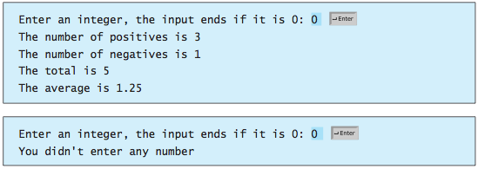

**Question 2:**

Write a program that displays, ten numbers per line, all the numbers from 100 to 200 that are divisible by 5 or 6, but not both. The numbers are separated by exactly one space.

**Question 3:**

Use the following solution to find the greatest common divisor of two integers **n1** and’ **n2.**

First find **d** to be the minimum of **n1** and **n2**, and then check whether **d**, **d - 1**,**d – 2**, ... , **2**, or **1** is a divisor for both **n1** and **n2** in this order. The first such common divisor is the greatest common divisor for **n1** and **n2**.

**Challenge Question (optional)**

**This question will not be graded.**

Write a nested **for** loop that displays the following output:

